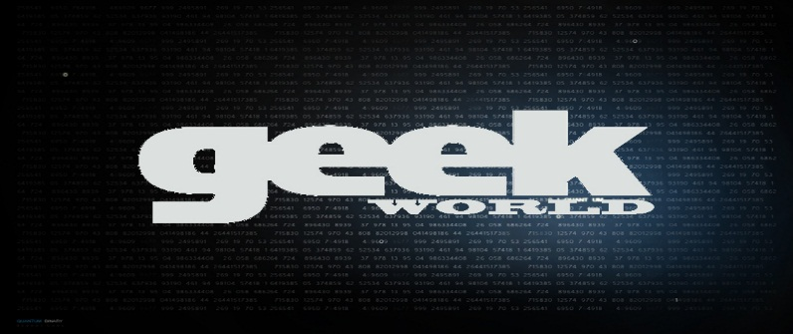

Geekworld is a website created using HTML, CSS, ,Java Script, PHP, and MYSQL. The primary objective of Geekworld is to provide necessary information for the Geeks of the world. The long term objective is to help the Geeks get relevant technology, fun, movies, quizzes and all the information pertating to Geeks.

The website is divided into : Home page, Geekepidia, News, Quiz, Feedback and About us.

Home page:

It is made to look attractive to the Geeks. It has button and image links to all th parts of the website . It also has a Search Engine. Search Engine is a special feature of our website. Search Engine is like a librarian of our website. All the keywords from all the pages will be extracted and it will be inserted in a binary search tree, so that the keywords are stored in a systematic manner. Search Engine takes the keyword from the user , checks if that keyword is present in the Binary Search Tree and it returns the link of the keyword.

Geekepidia:

It is wikipidia for the geeks. It potentially has all the information the geek needs, starting from geek movies and books. We can expand this page to contain everything geeks look for including technology and space

information. The technology used here is mostly HTML, Java Script and CSS.

News:

It contains informational about what is happening around the world related to science , technology and general news.

Quiz:

This page is provided to entertain and challenge the geeks. It also a new feature where the new questions can be added by the user. This page basically takes the result from the quiz stores it in the database and returns the score achieved by the participants. The technology used here is mostly HTML, PHP , MYSQL and CSS.

Feedback form:

It is provided for the users to provide constructive feedback. The feedback and the user information is stored in the database. The technology used here is mostly HTML, PHP , MYSQL and CSS.

About us:

It contains the information about the Web Design team and their ideology.

BY:

Arun John 01FB15ECS053

Abhilash Kashyap 01FB15ECS006

Mayank Kejriwal 01FB15ECS362